EXPERIMENT 6
IMPLEMENTION OF RAIL FENCE CIPHER

Aim:
To implement the Rail Fence transposition technique using Python.

Algorithm:
• Read the plaintext.
• Arrange the text in a zigzag pattern.
• Read row by row.
• Display the encrypted text.

Code:
rails = int(input("Enter Number of Rails: "))
plaintext = input("Enter Plain Text: ")
rail = [["" for i in range(len(plaintext))] for j in range(rails)]
row = 0
direction = 1
for col in range(len(plaintext)):
rail[row][col] = plaintext[col]
if row == 0:
direction = 1
elif row == rails - 1:
direction = -1
row += direction
encrypted = ""
for i in range(rails):
for j in range(len(plaintext)):
if rail[i][j] != "":
encrypted += rail[i][j]
rail = [["" for i in range(len(plaintext))] for j in range(rails)]
row = 0
direction = 1
for col in range(len(plaintext)):
rail[row][col] = "*"
if row == 0:
direction = 1
elif row == rails - 1:
direction = -1
row += direction
index = 0
for i in range(rails):
for j in range(len(plaintext)):
if rail[i][j] == "*":
rail[i][j] = encrypted[index]
index += 1
decrypted = ""
row = 0
direction = 1
for col in range(len(plaintext)):
decrypted += rail[row][col]
if row == 0:
direction = 1
elif row == rails - 1:
direction = -1
row += direction
print("Encrypted Text:", encrypted)
print("Decrypted Text:", decrypted)

Output:
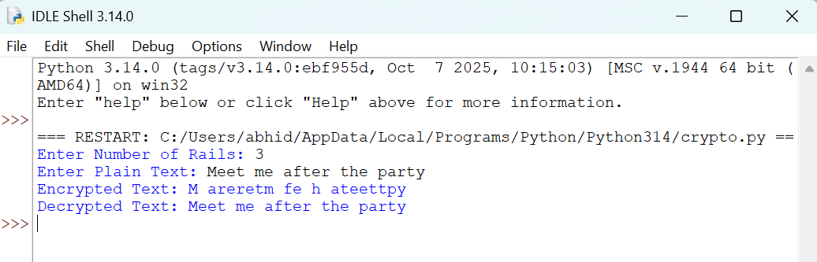

Result:
Thus, the Rail Fence transposition technique was implemented successfully
using Python.

